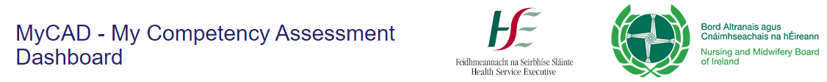

Guide for Preceptor/Associate Preceptor and Registered Nurse to use MyCAD.ie

To use the site you need to create an account by going to the Home Page for the site which is https://mycad.ie
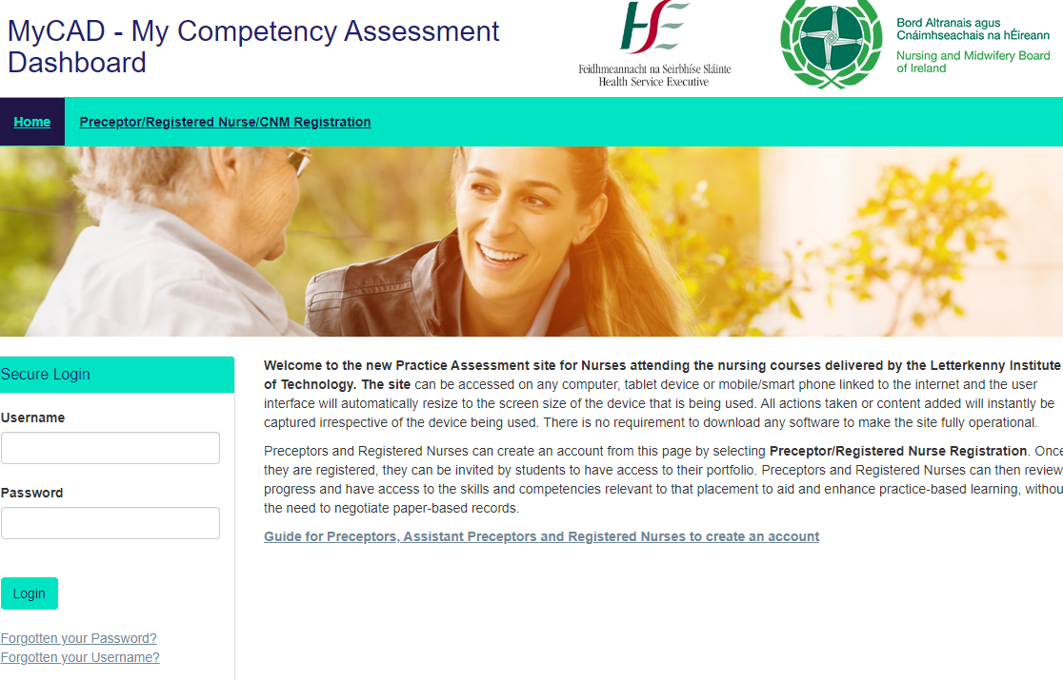
In the top banner select Preceptor/Registered Nurse/CNM Registration. The form below will appear.
Please note that is usual to enter your work email address however it is not mandatory to do this, if you do not have one. It is important that you enter these details correctly because it is the address the site uses if you have forgotten your password.
The site will only allow you to create an account with the same e-mail address once. Please avoid creating more than one account for yourself. If you have forgotten your password or username please select the ‘Forgotten Your Password’ and ‘Forgotten Your User name’
Please note that Student/Clinical Placement Co-ordinators and Link Lecturer accounts are created by the Admin team.
Once you have entered that address select Continue and the following form appears.
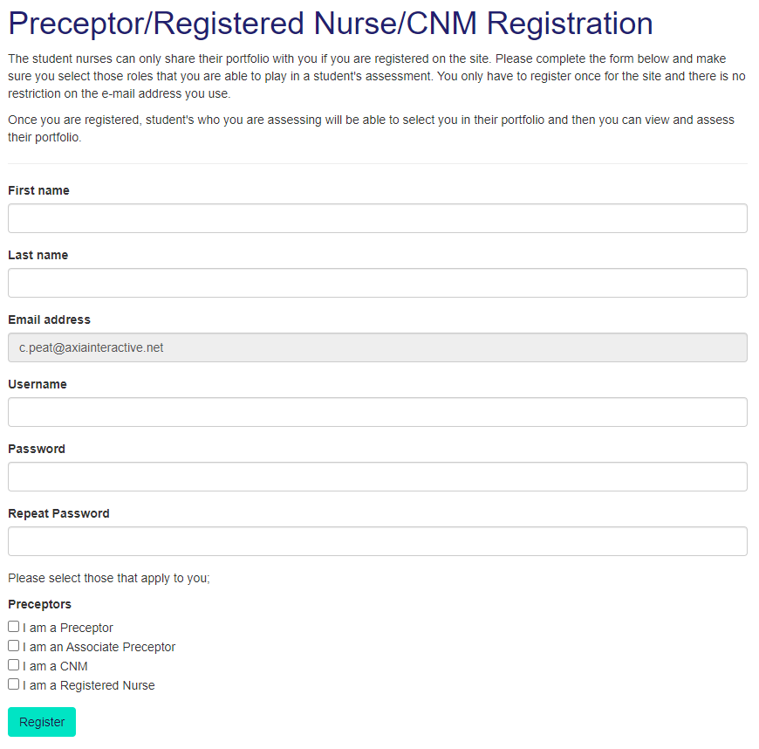
Please select all the roles that apply to you. When the students then select the professionals who will be supporting them on their placement, your details will appear for them, and they can select you.
In advance of the Placement starting the Clinical Placement Co-ordinators will work with the students to set up their Placement. However, they can only select Preceptors/Associate Preceptors/Registered Nurses if you have an account.
You only need to set up an account once.
Each student can have multiple Preceptors/Associate Preceptors/Registered Nurses/Clinical Placement Co-ordinators/Link Lecturers supporting them on a placement.
This is what the student sees;
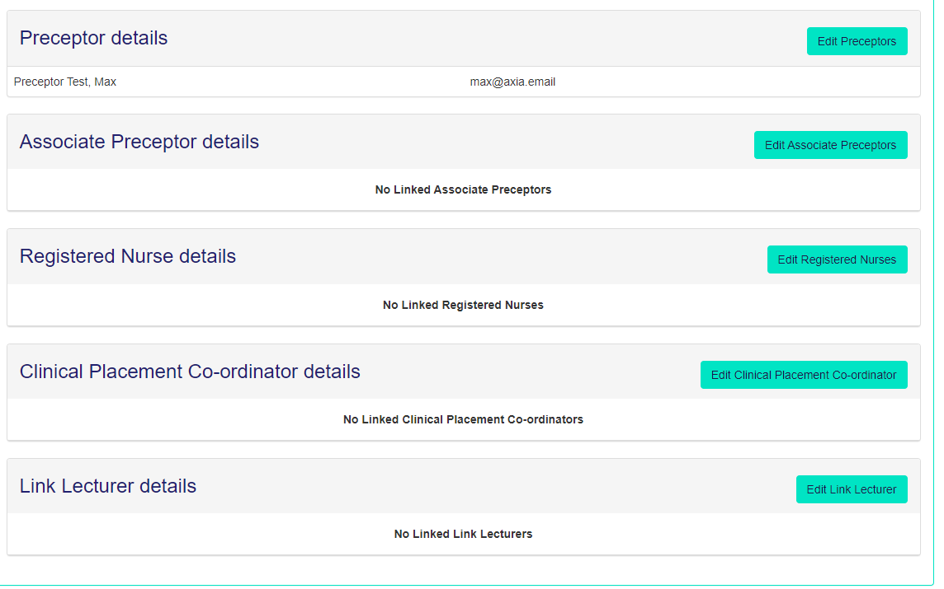
If they then select ‘Edit Preceptors’ they can search for you, but you will only appear if you are registered.
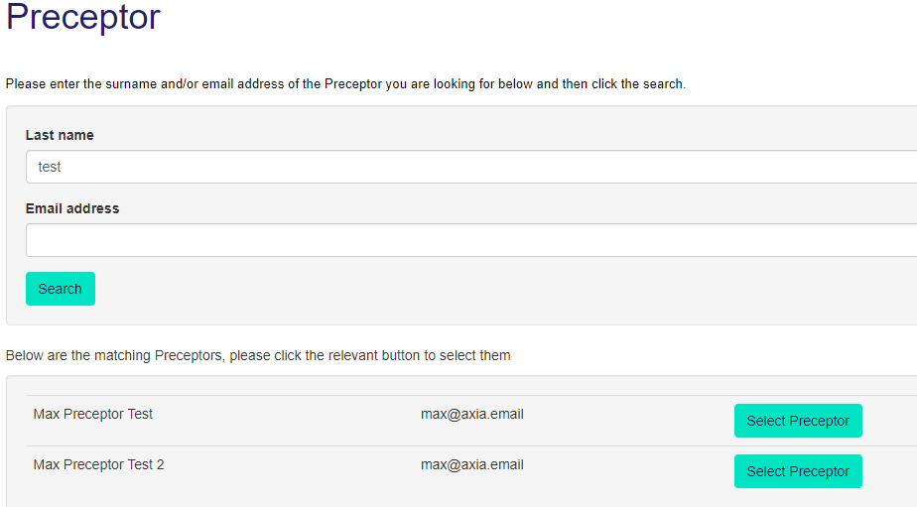

The site then controls what you can do based on the role you are performing for that student on that placement. Until you are selected by student(s) you cannot see their portfolio. Once you are then you will see the illustration below. The content is the same as what you now see when using the paper document.
All the headings that are underlined are links. If you put your mouse on the link then the appropriate page will appear.
Whichever page you are working as a Preceptor/Assistant Preceptor/Registered Nurse there is always a direct link back to the home page of a student’s portfolio from where you can access other pages. Just select ‘Go to Student Dashboard’.
This is the student dashboard and you can directly access any page from here.
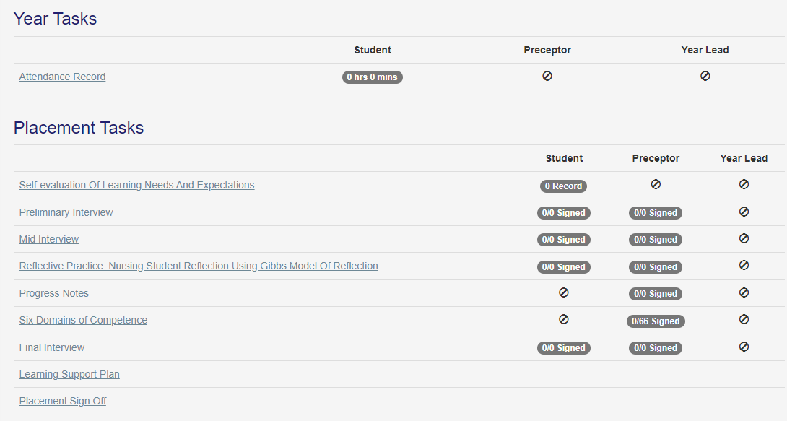

For example, this is what appears when selecting the Six Domains of Competence. A couple of the competencies have been signed to illustrate how the site dates the signature and records who has signed it.
There is no requirement to add your signature, the site knows what passport protected user name has been used to sign off the competence.
When the student opens the same page, they do not have the ability to sign off a competence.
Please note that the system will display the correct competencies based on the type of placement that has been selected.

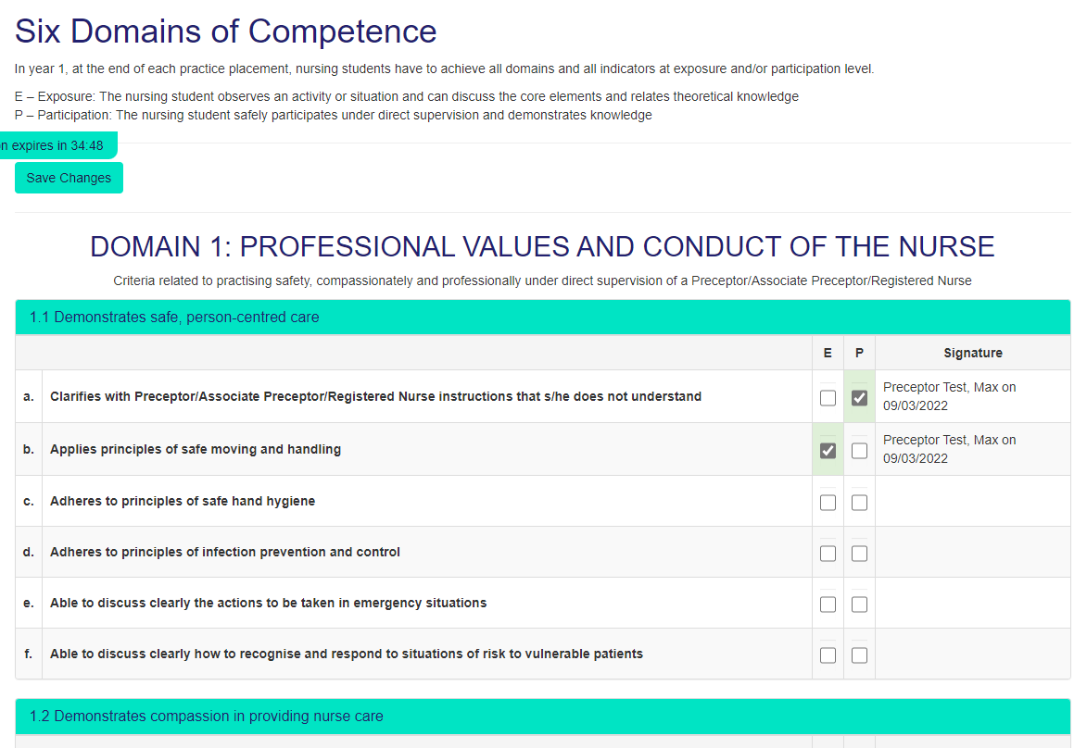
There are other pages where the student can add their content ideally before the Preceptor/Assistant Preceptor adds their comments.
This is the page for the Mid Interview.
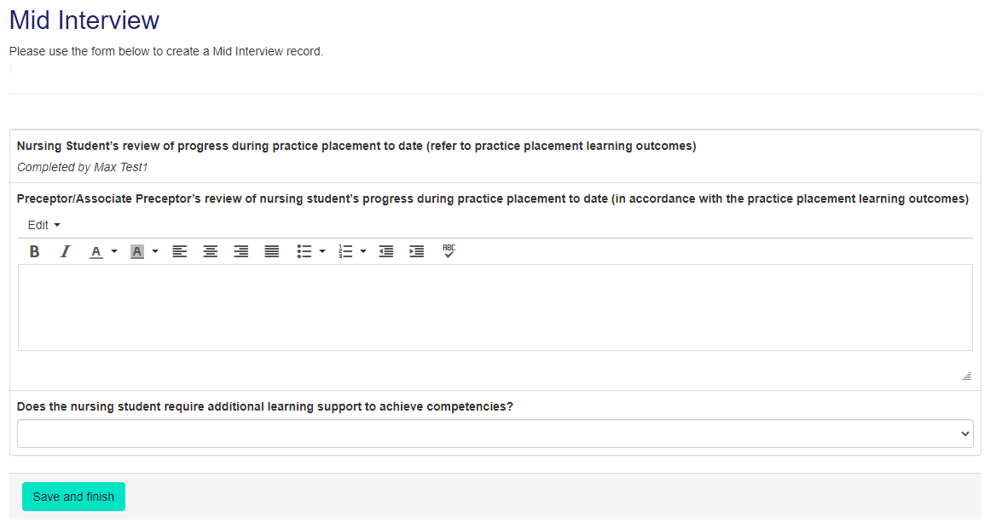
The Attendance Record works in a similar way with the student attending details of their attendance, confirming that this is a correct record and then the Preceptor/Assistant Preceptor/Registered Nurse can confirm the hours. The system then automatically calculates the hours and the hours can also be viewed by CPCs and Admins.
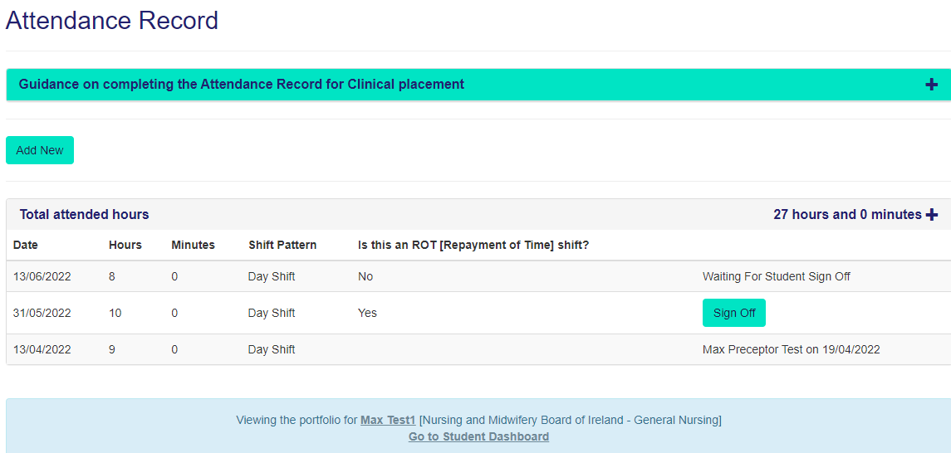

You will note that at the top of the page there is a Timer which reminds you that as with other secure documents e.g. bank statements you are logged out if there has been no interaction with a page. In the case of MyCAD this is set at 35 minutes, however this timer is reset whenever you have taken an action with the site e.g., moved to a new section or typed in some content.
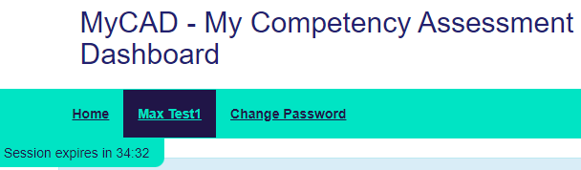

Finally, some top tips;
- You can use any electronic device that is connected to the internet to access the site including your mobile phone.
- Always remember to ‘Save’ whatever content you have added.
- When working with a student make sure that if you are completing a form together that you log-in as a Preceptor and then log out before the student adds their content/signature or vice versa.
- You can view the whole portfolio by selecting the print icon at the top of the page.
We hope it goes well and welcome any feedback.

