

Guide for creating Preceptor/Associate Preceptor and Registered Nurse Accounts

Go to the Landing Page of the site by typing in https://mycad.ie
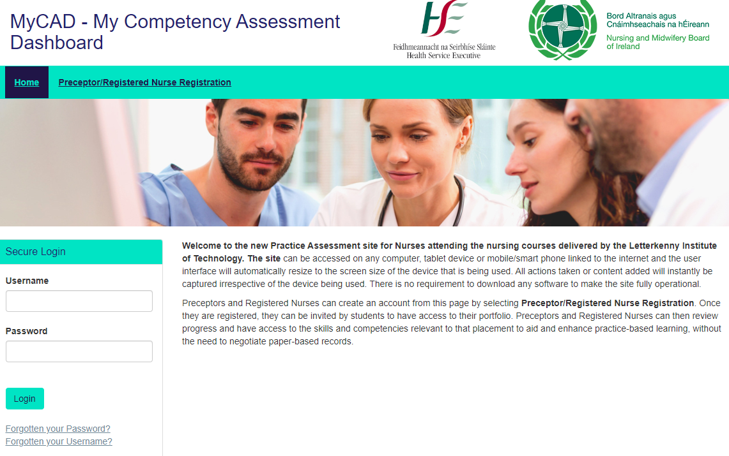
In the top banner select Preceptor/Registered Nurse Registration. The form below will appear.
Please note that is usual to enter your work email address however it is not mandatory to do this, if you do not have one. It is important that you enter these details correctly because it is the address the site uses if you have forgotten your password.
The site will only allow you to create an account with the same e-mail address once. Please avoid creating more than one account for yourself. If you have forgotten your password or username please select the ‘Forgotten Your Password’ and ‘Forgotten Your User name’

Once you have entered that address select Continue and the following form appears.
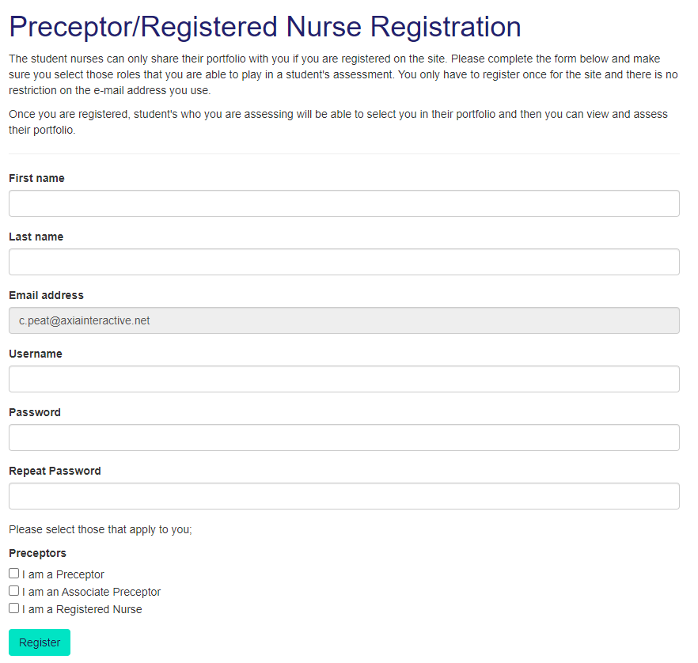
Please select all the roles that apply to you. When the students then select the professionals who will be supporting them on their placement, your details will appear for them and they can select you. This is what the student sees;
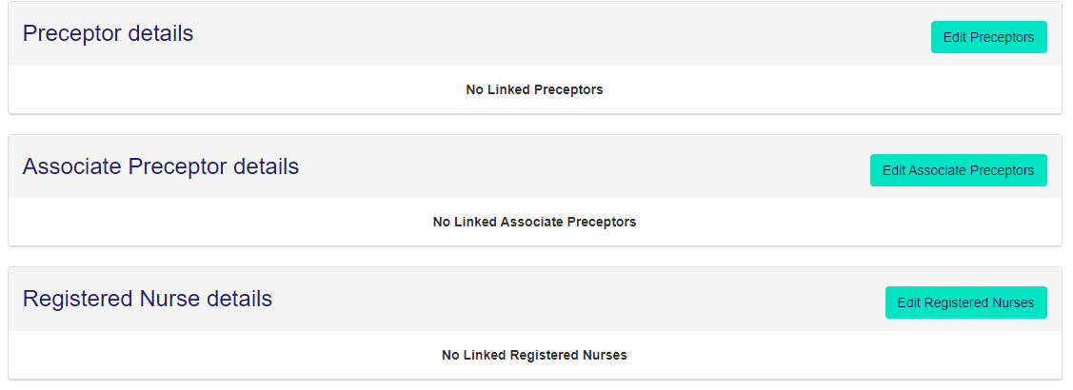
If they then select ‘Edit Preceptors’ they can search for you, but you will only appear if you are registered.
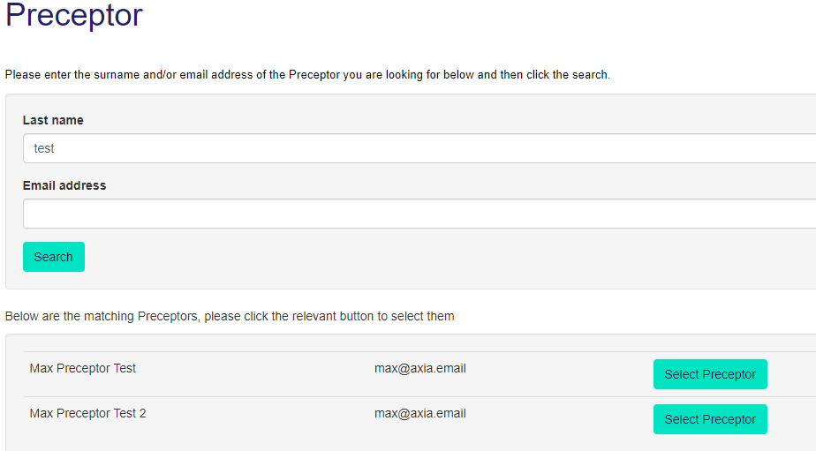

The site then controls what you can do based on the role you are performing for that student on that placement. Until you are selected by student(s) you cannot see their portfolio. Once you are then you will see the illustration below. This is exactly what you now see when using the paper document.
All the headings that are underlined are links. If you put your mouse on the link then the appropriate page will appear.

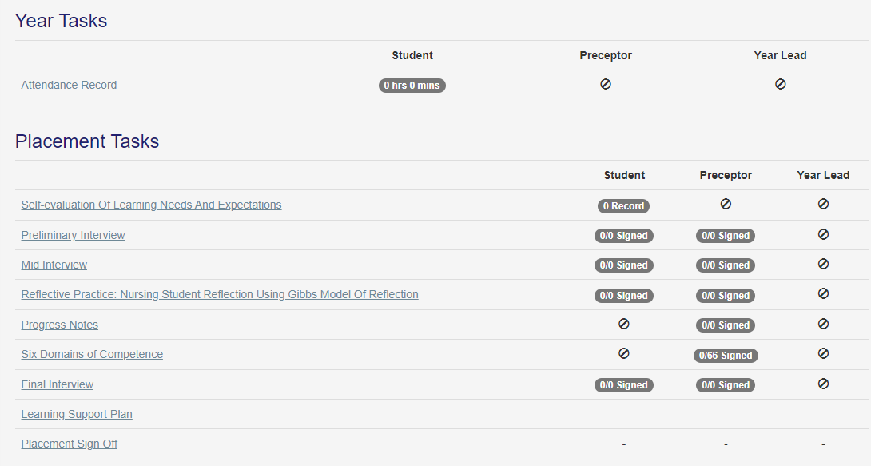

For example, this is what appears when selecting the Six Domains of Competence. A couple of the competencies have been signed to illustrate how the site dates the signature and records who has signed it.
There is no requirement to add your signature, the site knows what passport protected user name has been used to sign off the competence.
When the student opens the same page, they do not have the ability to sign off a competence.
Please note that the system will display the correct competencies based on the type of placement that has been selected.
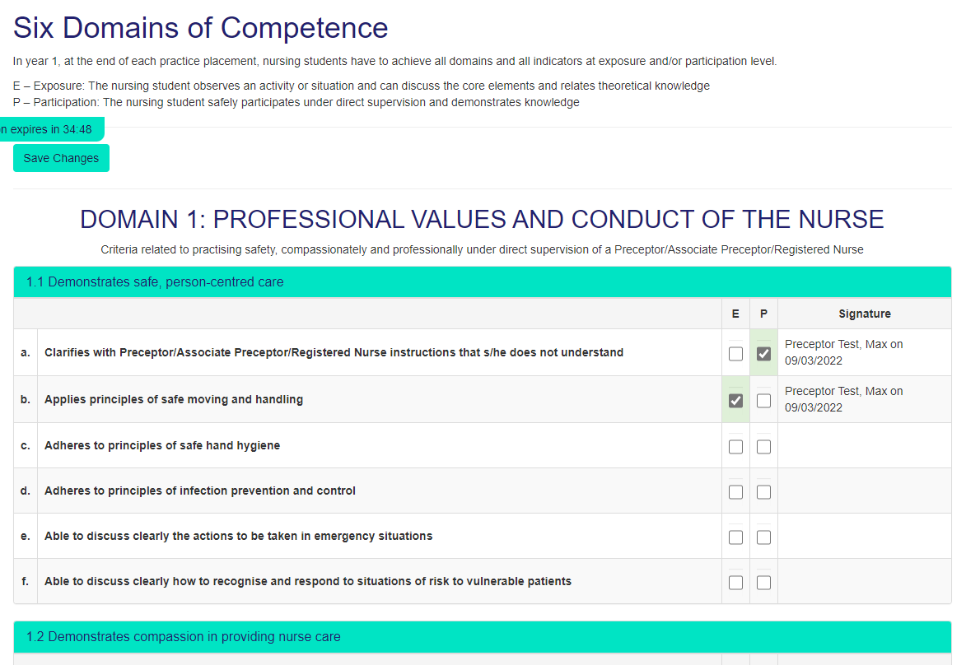
Finally, some top tips;
- You can use any electronic device that is connected to the internet to access the site including your mobile phone.
- Always remember to ‘Save’ whatever content you have added.
- When working with a student make sure that if you are completing a form together that you log-in as a Preceptor and then log out before the student adds their content/signature or vice versa.
- You can view the whole portfolio by selecting the print icon at the top of the page.
We hope it goes well and welcome any feedback.

