

Guide for Students to use MyCAD.ie

Your username and password will be created for you by the admin team. To use the site go to the Home Page for the site which is https://mycad.ie

We recommend that after you have logged in for the first time you change your password to one that is more memorable to you.
Select ‘Change Password’ on the home page.
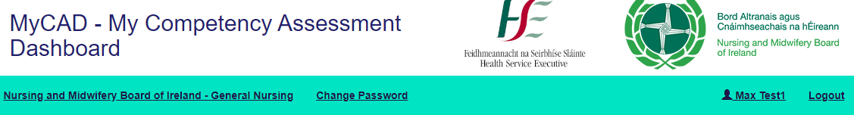
Before starting your placement, your Clinical Placement Co-ordinator will work with you to create your placement on MyCAD. You need to first select your placement; confirm the type of placement that it is and then create relationships with the Preceptors; Associate Preceptors; Registered Nurses and Link Lecturer that will be supporting you on this placement.
By relationship we mean those people who you are allowing to interact with your portfolio to sign off attendance records.
Please note that if the Preceptors; Associate Preceptors; Registered Nurses details are not there when you search for them, then you will need to ask them to add their details when you arrive on placement.
If the details of the Placement you are going to are not in the system, then you can ask your CPC or the Admin team to add these details when you are setting up the Placement.
Adding the Placement Details.
Go to the Placement Details section on the Home Page and select ‘Edit Details’. The following page will appear.
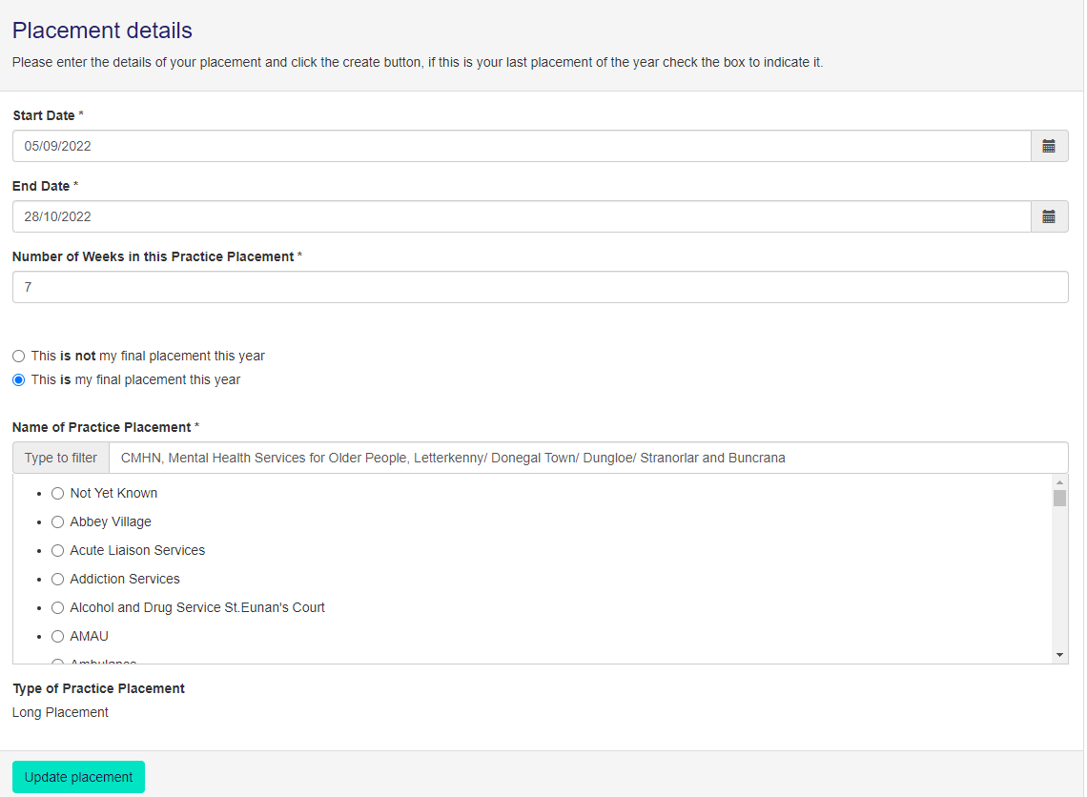
You need to add the Start and End Date for the Placement.
It is then important that you add the correct number of weeks for the Placement. If you unsure add your CPC for advice. The number of weeks determines the type of assessment document that will be presented for that placement, and it is important you get this right.
You also need to confirm whether this is the final placement for the year
You can then find your placement either by starting to add the details in Search box at the top of this section or by scrolling through the list.
The confirm the Placement by selecting ‘Update Placement’
Please note that it is possible to have assessment documents for different placements available at the same time but not for the same date period.
Creating the Assessment relationships for this placement.
Each student can have multiple Preceptors/Associate Preceptors/Registered Nurses/Clinical Placement Co-ordinators/Link Lecturers supporting them on a placement.
This is what the student sees;
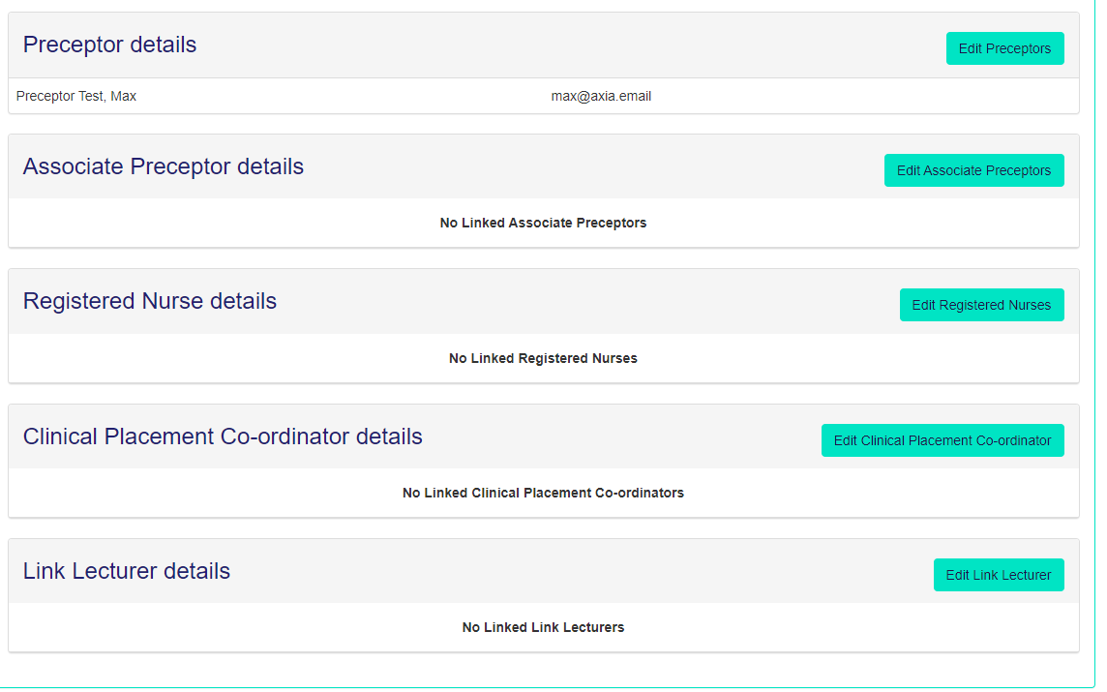
If they then select ‘Edit Preceptors’ they can search for you, but you will only appear if you are registered.
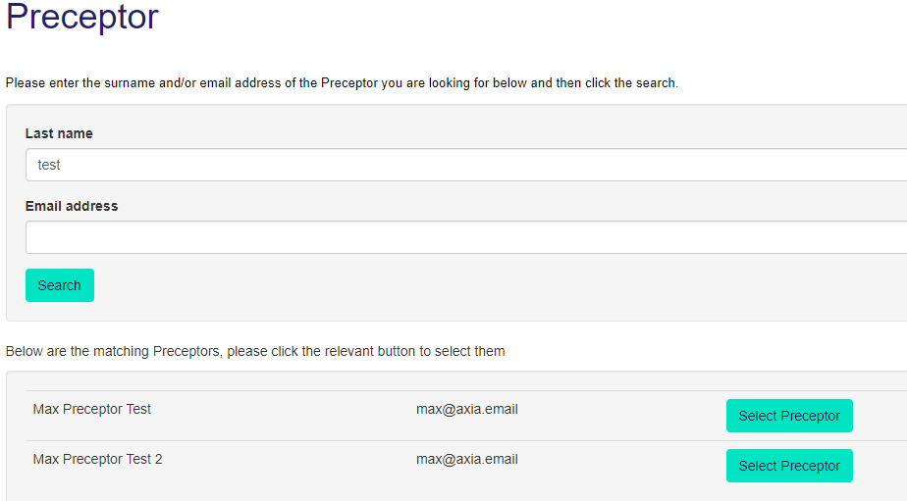

The site then controls what you can do based on the role you are performing for that student on that placement. Until you are selected by student(s) you cannot see their portfolio. Once you are then you will see the illustration below. The content is the same as what you now see when using the paper document.
Please note the site allows you to have multiple placements open at one time.
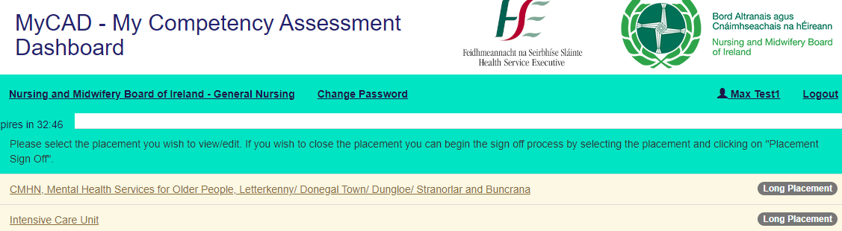
All the headings that are underlined are links. If you put your mouse on the link then the appropriate page will appear.

This is the student dashboard and you can directly access any page from here.
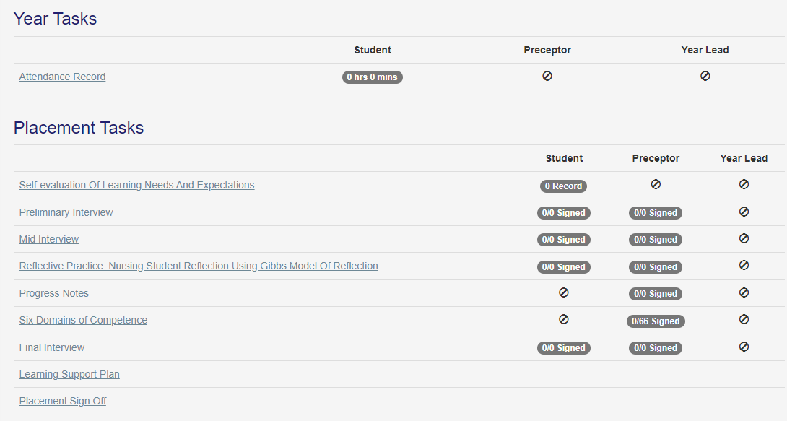

For example, this is what appears when selecting the Six Domains of Competence. A couple of the competencies have been signed to illustrate how the site dates the signature and records who has signed it.
There is no requirement to add your signature, the site knows what passport protected user name has been used to sign off the competence.
When the student opens the same page, they do not have the ability to sign off a competence.
Please note that the system will display the correct competencies based on the type of placement that has been selected.

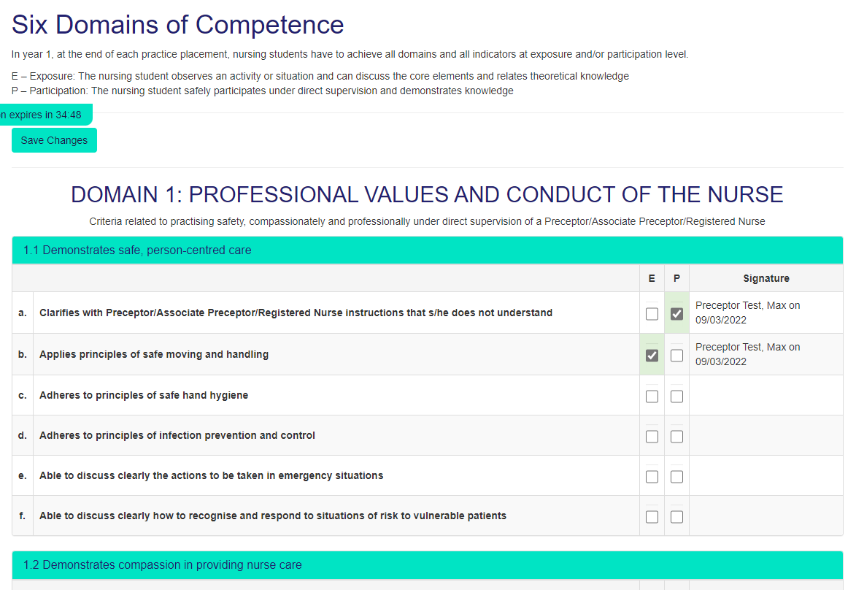
There are other pages where you can add your content ideally before the Preceptor/Assistant Preceptor adds their comments.
This is the page for the Mid Interview.
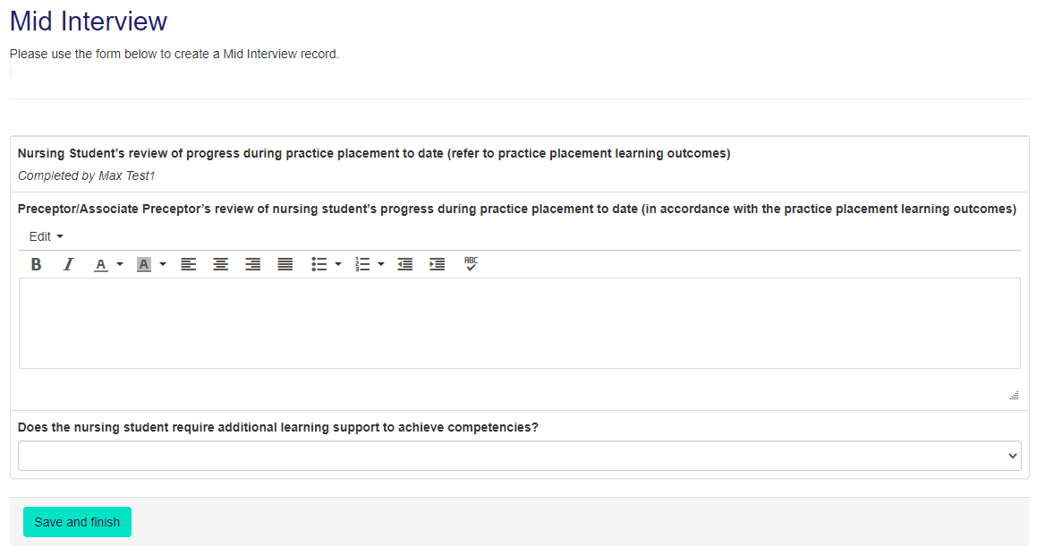
The Attendance Record works in a similar way with you attending details of their attendance, confirming that this is a correct record and then the Preceptor/Assistant Preceptor/Registered Nurse can confirm the hours. The system then automatically calculates the hours and the hours can also be viewed by CPCs and Admins.
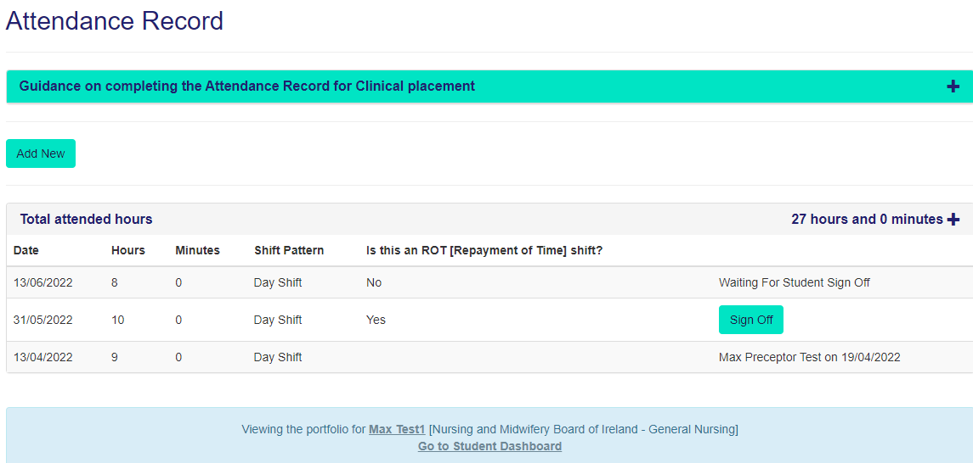

This is what appears when you select Attendance Record. Complete the details of your shift and/or other activity by selecting ‘Add New’. This is what appears.
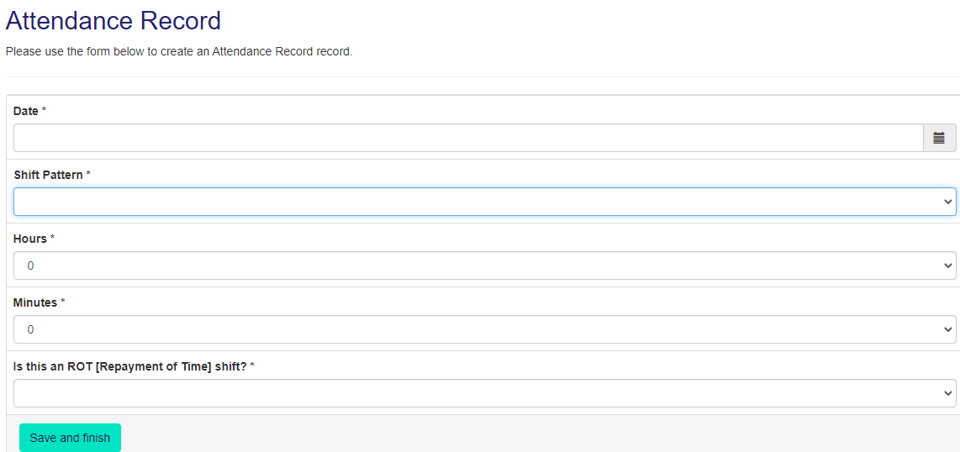
Select the Arrows at the end of the box to choose the correct option for the Attendance Record.
Once you have created your attendance record, Sign it off. The system asks you to double check the record is correct.
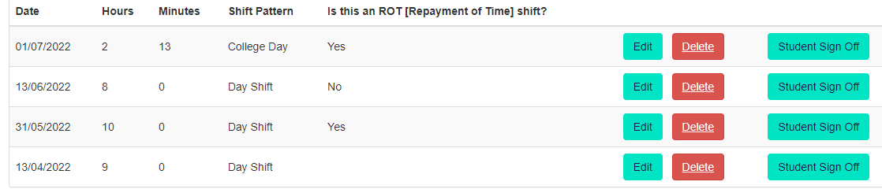
Once you have signed if off the record then becomes available to the Preceptor/Assistant Preceptor/Registered Nurse to sign if off. Once they have done this the ‘Total Attended hours’ will be amended.
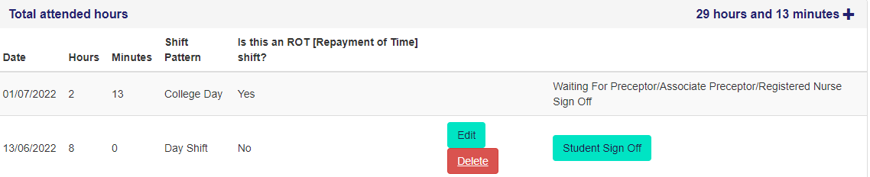
You will note that at the top of the page there is a Timer which reminds you that as with other secure documents e.g. bank statements you are logged out if there has been no interaction with a page. In the case of MyCAD this is set at 35 minutes, however this timer is reset whenever you have taken an action with the site e.g., moved to a new section or typed in some content.
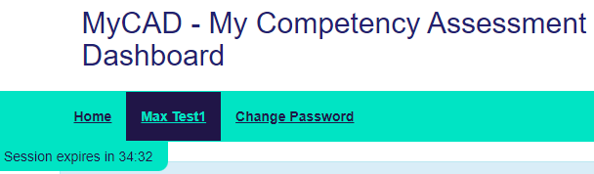

Finally, some top tips;
- You can use any electronic device that is connected to the internet to access the site including your mobile phone.
- Always remember to ‘Save’ whatever content you have added.
- When working with a student make sure that if you are completing a form together that you log-in as a Preceptor and then log out before the student adds their content/signature or vice versa.
- You can view the whole portfolio by selecting the print icon at the top of the page.
We hope it goes well and welcome any feedback.

