

Guide for Clinical Placement Co-ordinators and the Nursing Allocations Team to use MyCAD.ie

This Guide describes the specific report that has developed for the Clinical Placement Co-ordinators and Nursing Allocations Team.
Your username and password will be created for you by the admin team. To use the site go to the Home Page for the site which is https://mycad.ie

We recommend that after you have logged in for the first time you change your password to one that is more memorable to you.
Select ‘Change Password’ on the home page.
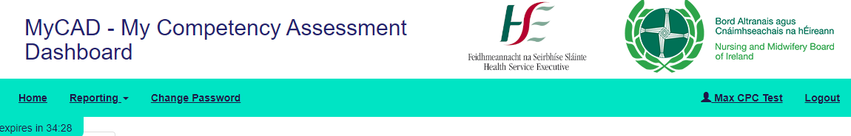

Special Report for the Clinical Placement Co-ordinators and Nursing Allocations Team.
A special report has been created that allows you to see immediately the attendance and other information for each cohort of students. There are two ways for you to see student’s attendance records and/or their portfolio.
You can use the list of all those students who have selected you as their CPC called ‘Students on Active Placement’. Search for your student either by using the Filter just below ‘Students on Active Placement’ or scroll down the list. Select ‘View’ and the Student’s portfolio will appear
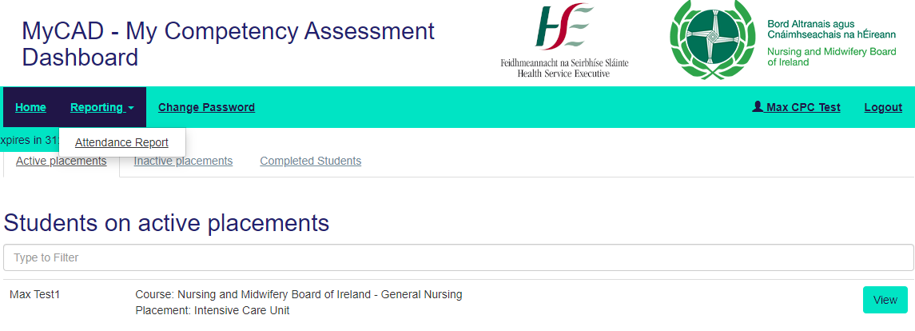

Alternatively, you can select Attendance Report and the following page will appear. This allows you to select the group of students you want to look at and for what period.
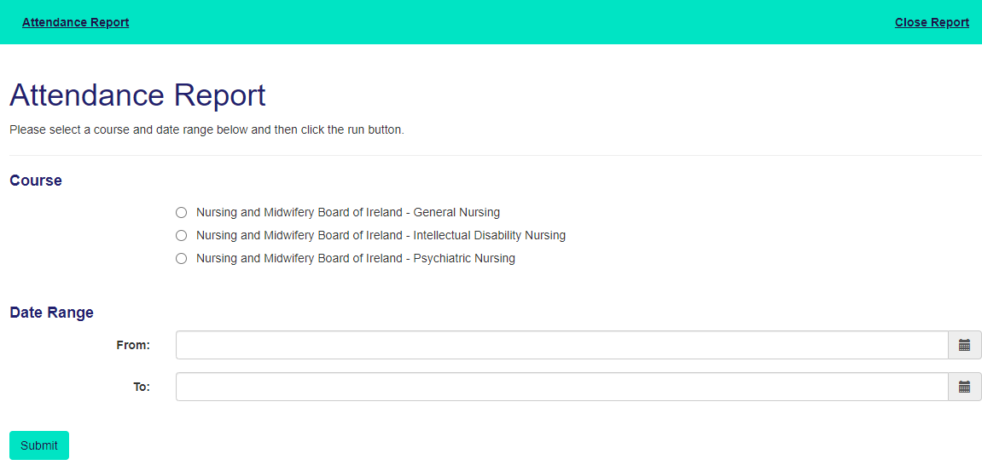

When you have made choices select ‘Submit’ and the following report appears.
This report is continually being updated as content is being added so what you see is the actual position in real time. The report gives you ‘Total Hours’ and ‘Total ROT hours’.

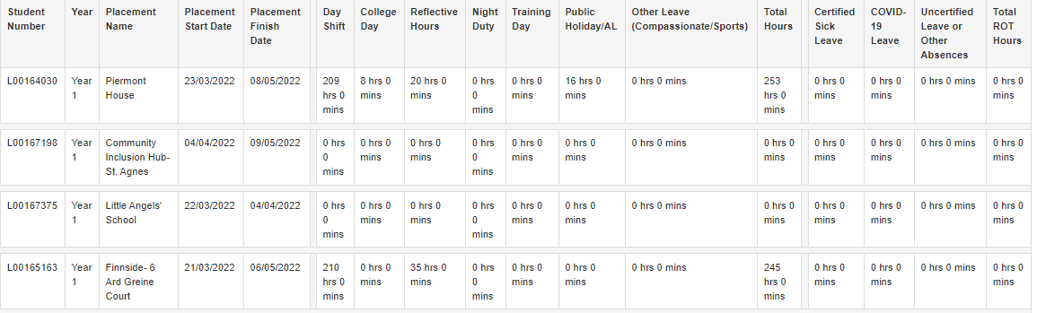
To maintain anonymity the illustration above does not show that at left hand side of the report there are the names of each student.
That name is a link to the full portfolio.
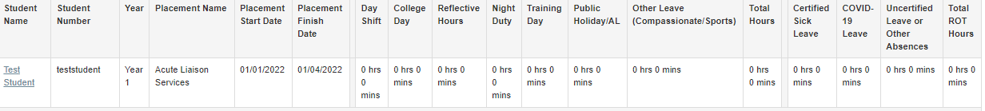
If that link is selected the dashboard for that student’s portfolio appears and you can directly access any page from here.
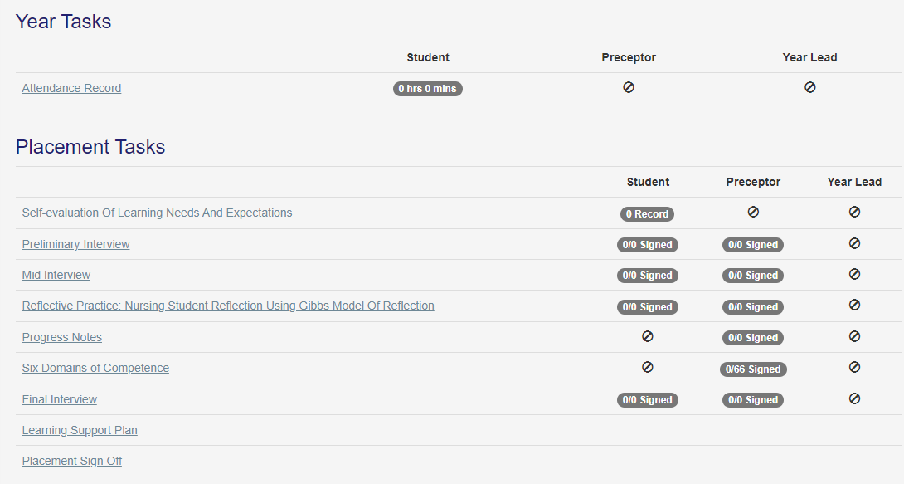
All the headings that are underlined are links. If you put your mouse on the link, then the appropriate page will appear.
Therefore, if you select ‘Attendance Record’ you can view the student’s attendance in detail.

There are other pages where you are permitted to add your content ideally before the Preceptor/Assistant Preceptor adds their comments.
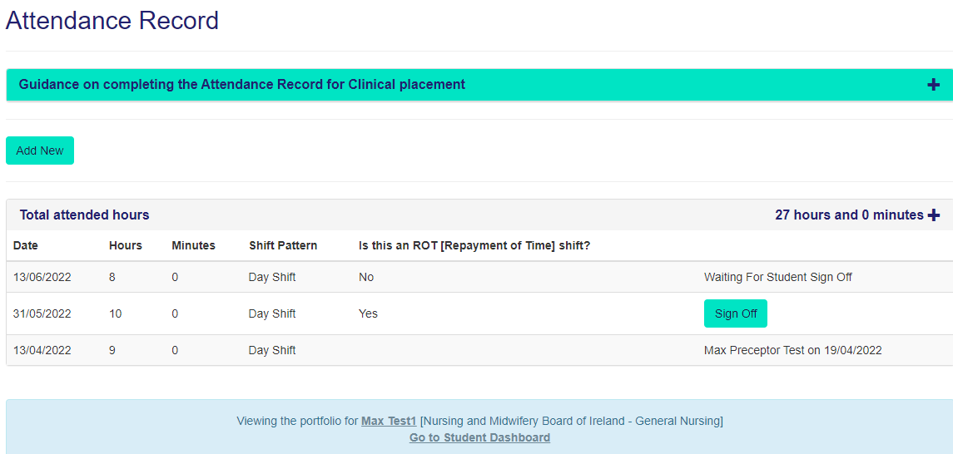
The Timer
You will note that at the top of the page there is a Timer which reminds you that as with other secure documents e.g. bank statements you are logged out if there has been no interaction with a page. In the case of MyCAD this is set at 35 minutes, however this timer is reset whenever you have taken an action with the site e.g., moved to a new section or type in some content.
